**1)Doctor Console App**

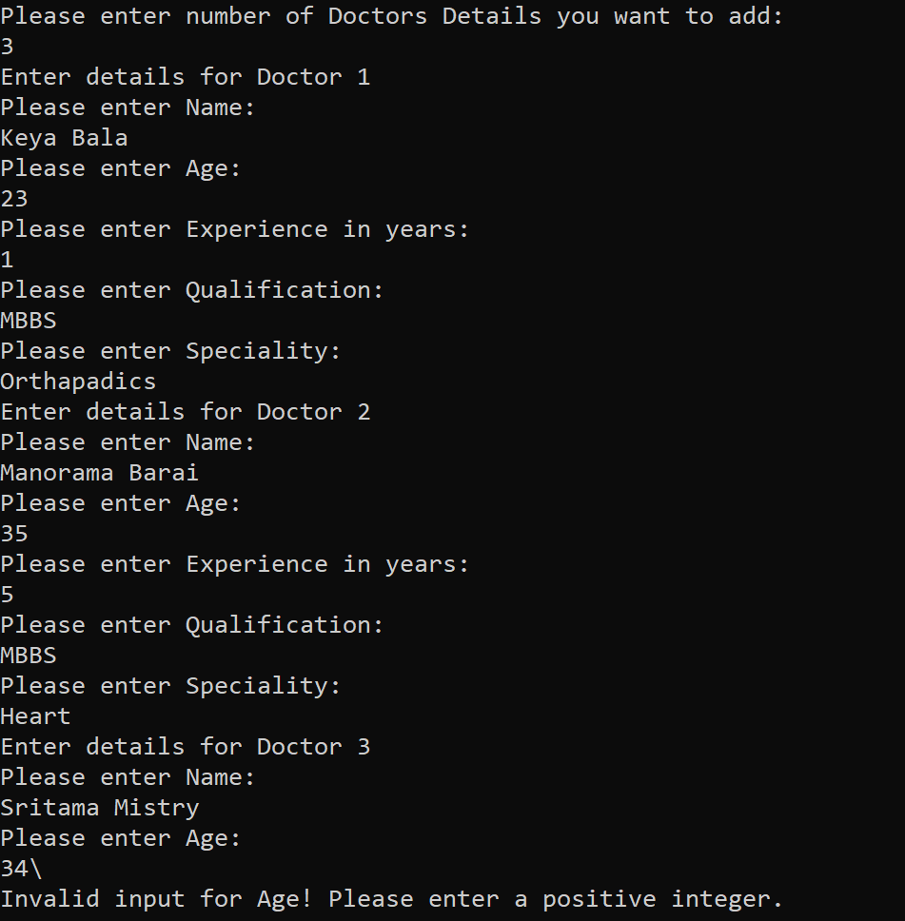

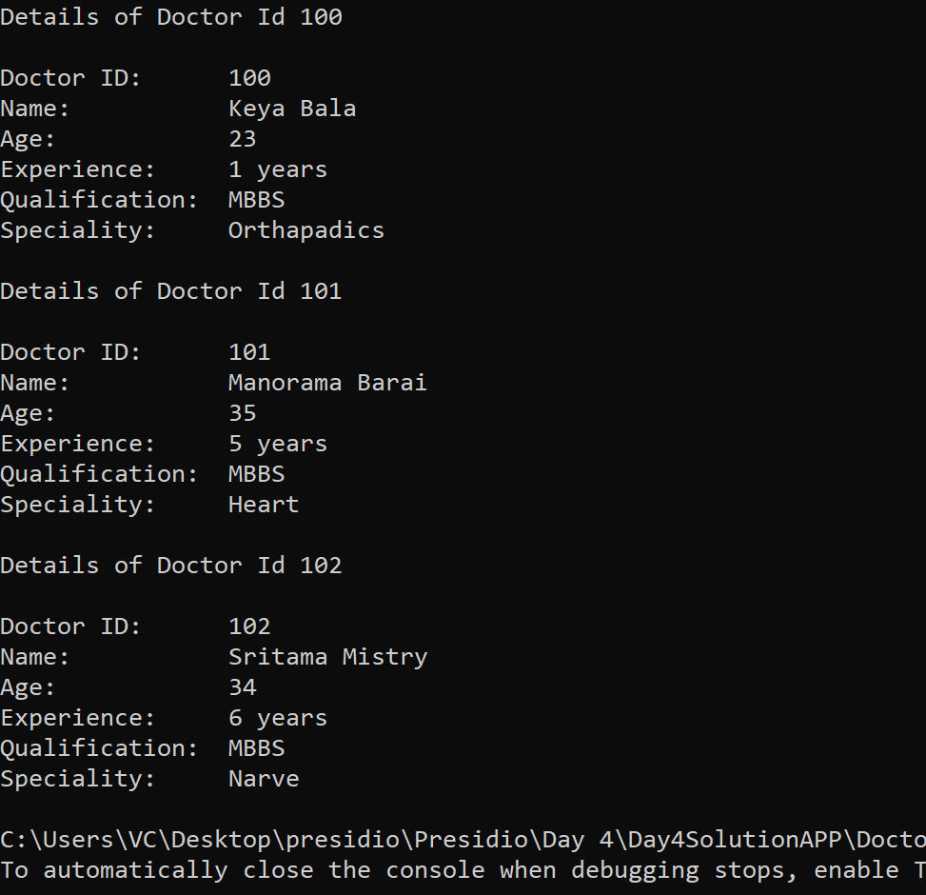

**2) Output Card Validation:**



